# **Build an Event Management System using Salesforce**

**INTRODUCTION :**

OVERVIEW

This project helps to develop a event management application using salesforce. Salesforce is Customer Relationship Management application which is being used in almost all companies to have a friendly relationship with the customer.In our project, we have created a event management application for corporate companies and also for public.

PURPOSE

It aims to produce areal time knowledge of the salesforce and how can we build a app using salesforce.in this project we build an event management application for corporates,which would be useful for the employees as well as to the companies to reduce time and manage the event management of the employees with ease.

**PROBLEM DEFINITION AND DESIGN THINKING :**

EMPATHY MAP

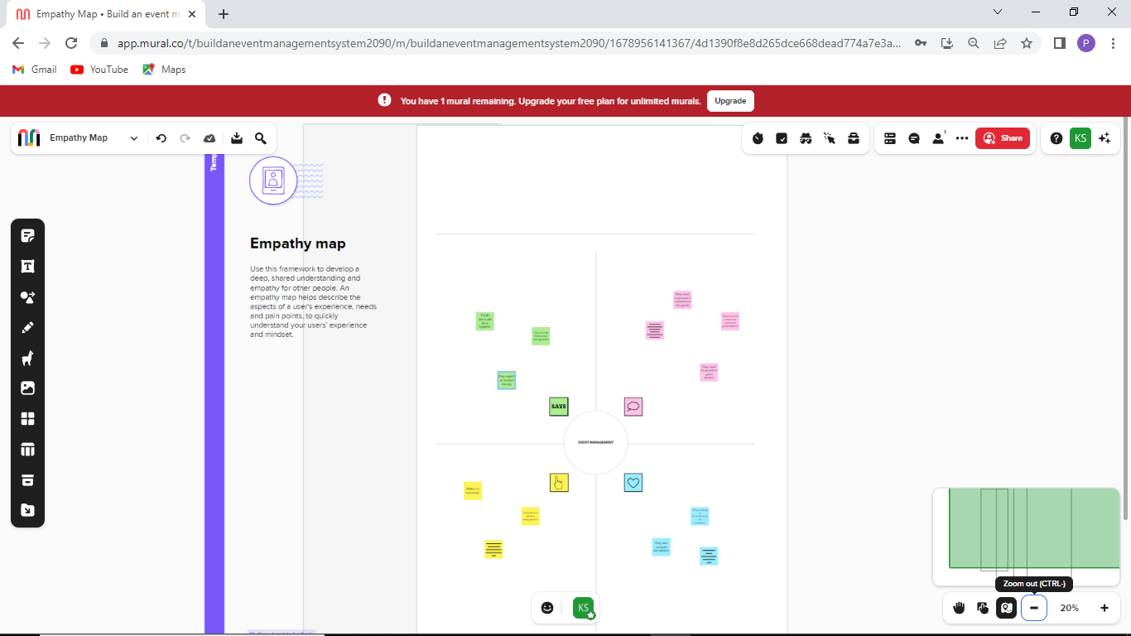

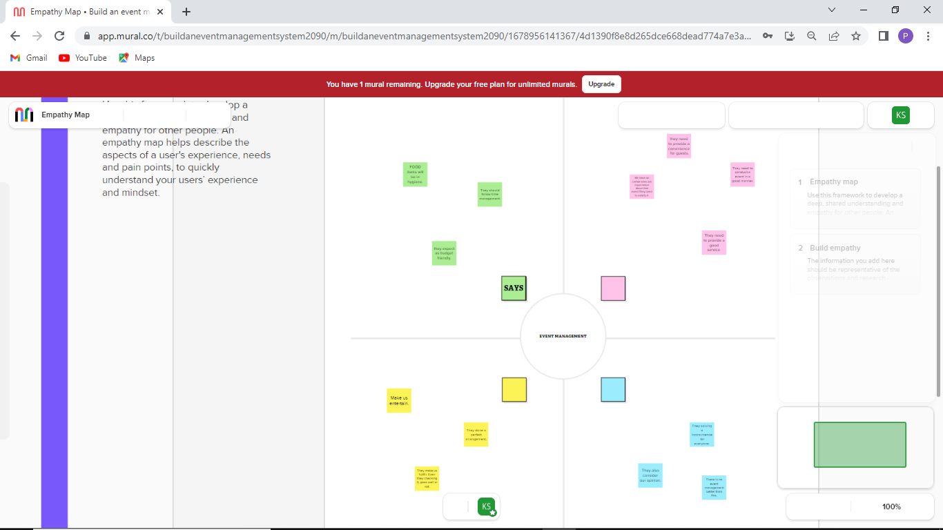

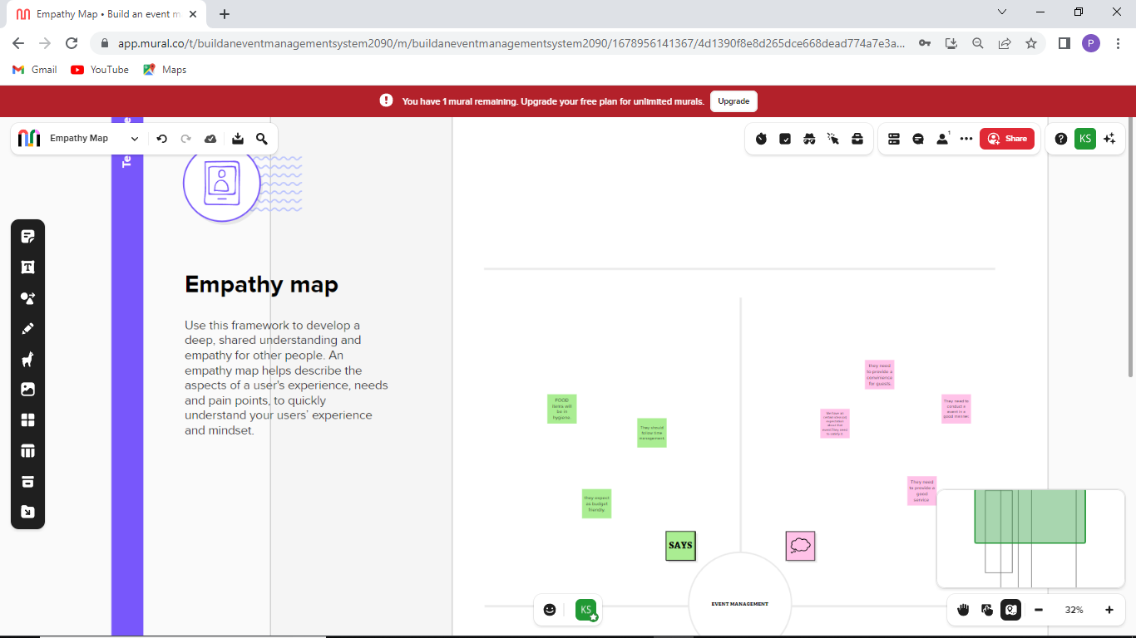

BRAINSTORMING AND IDEA PRIORITATION

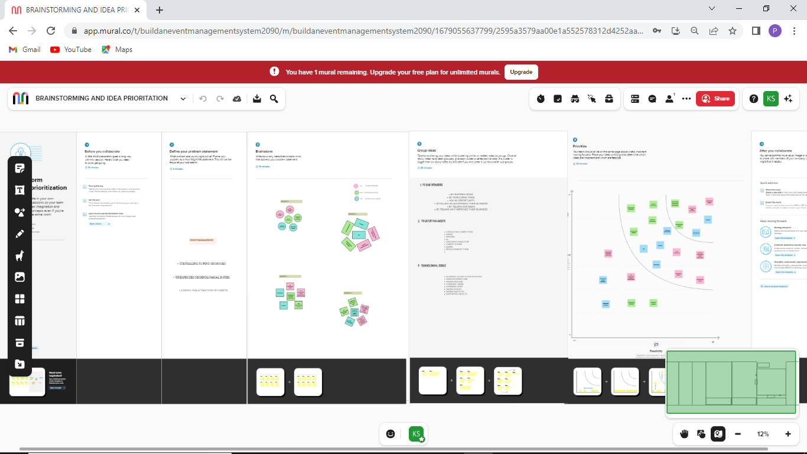

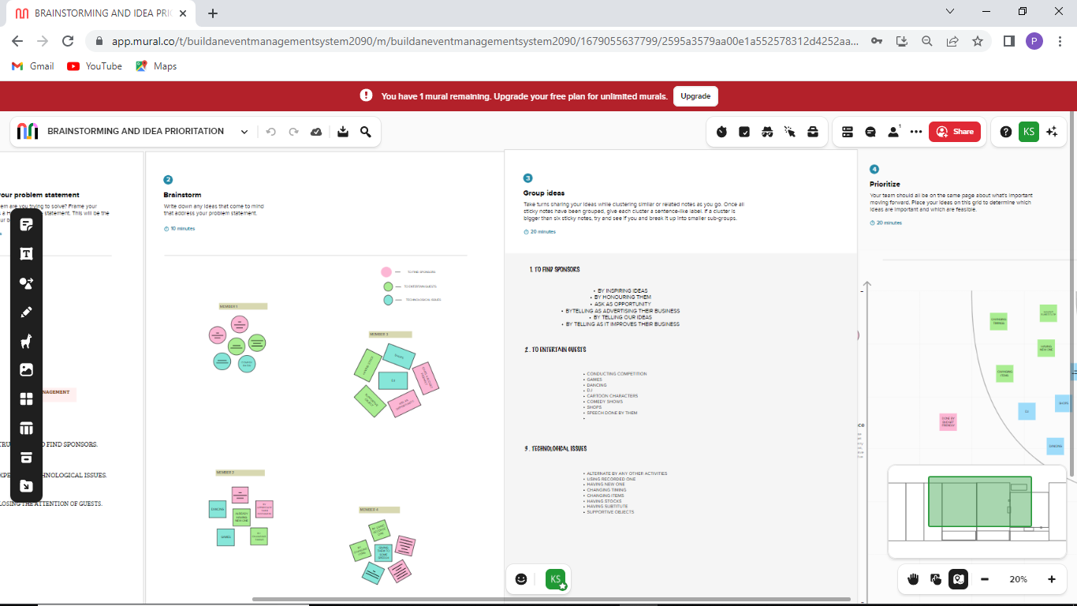

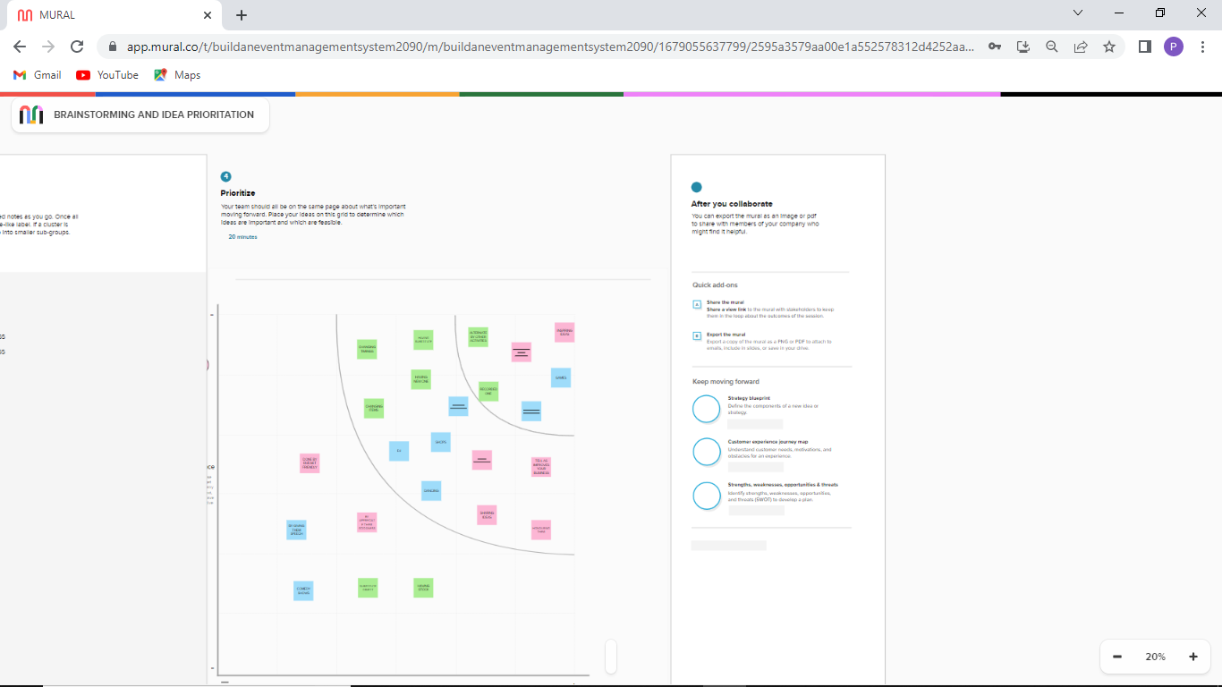

**RESULT :**

DATA MODEL

|  |  |  |
| --- | --- | --- |
| Object Name | Fields in the Object | |
| Field label | Data type |
| Event | City  Start date  End date  Event name | Text  Date/Time  Date/Time  Master – detail relationship |
| Attendees | Enter id  Phone  Email  Tickets | Auto number  Phone  Email  Picklist |
| Speakers | Bio  e-mail  Event name | Text area  Email  Look – up relationship |
| Vendors | e-mail  Phone  Service provider  Event name | Email  Phone  Text  Look – up relationship |

**ACTIVITY AND SCREENSHOT :**

CREATING AN SALESFORCE ACCOUNT

we went to the website developers.salesforce.com and signed up by giving our details.

LOGIN TO SALESFORCE ACCOUNT

we gave our username and password which we created in the last step and

logged in into the salesforce account.

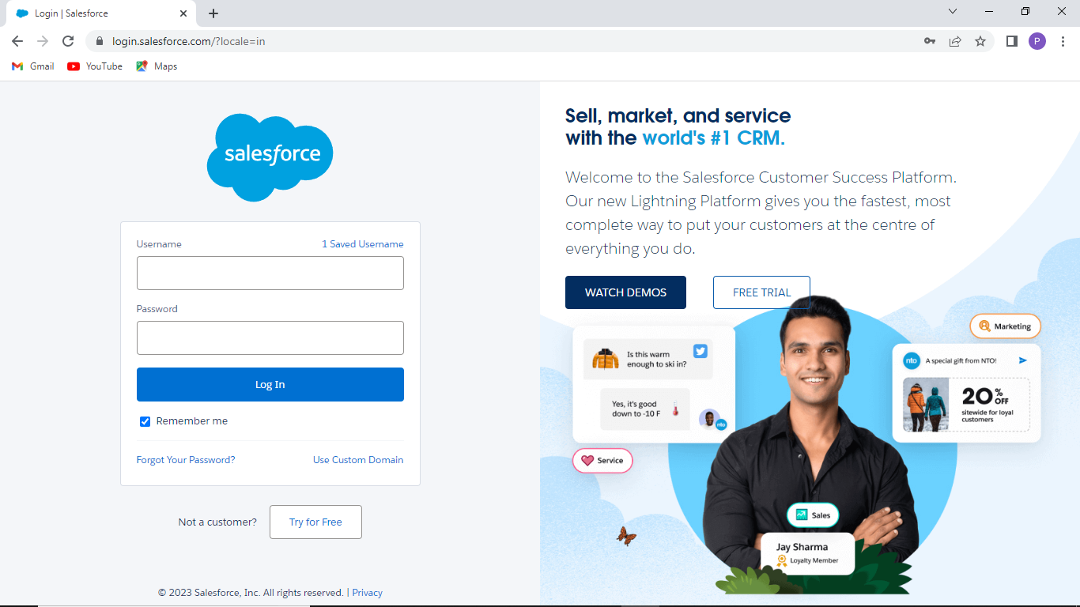

OBJECT CREATION

For this travel approval app ,we created four objects namely,

Events

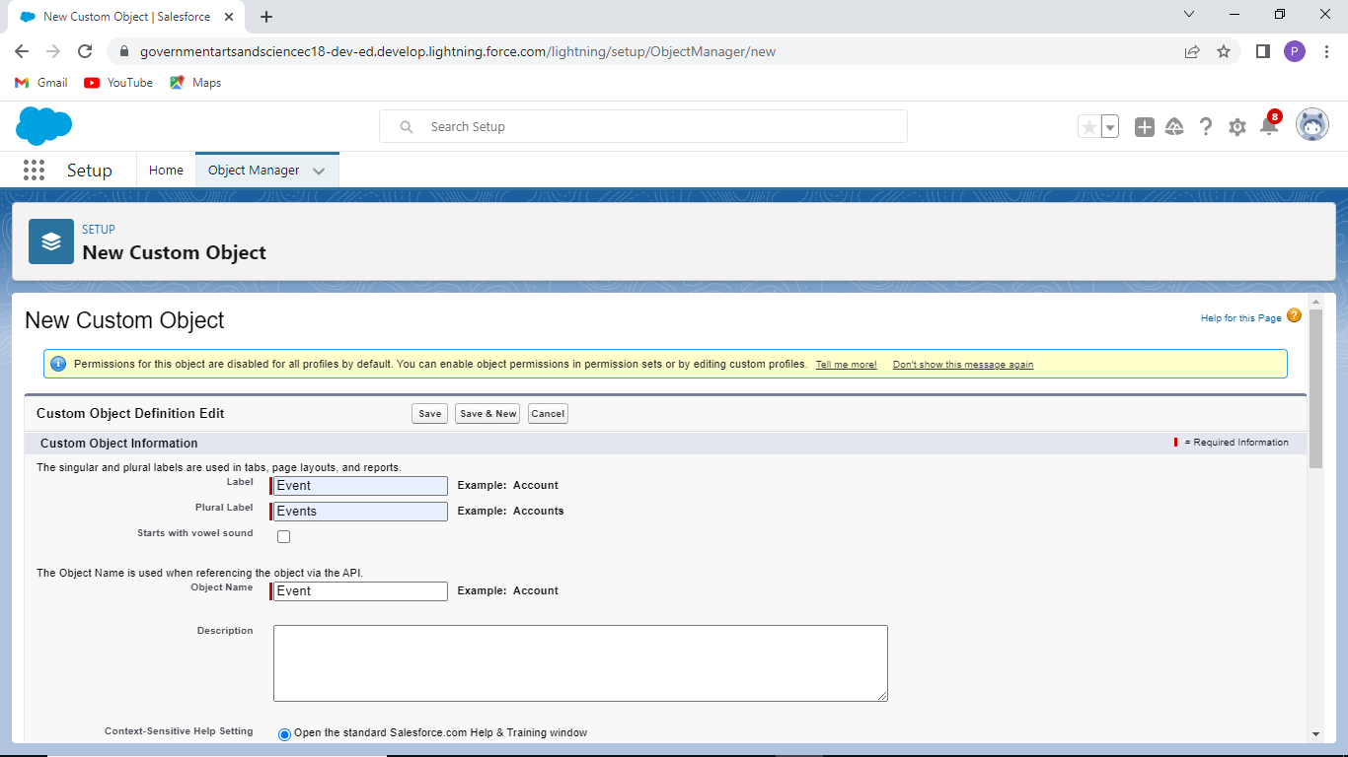

Attendees

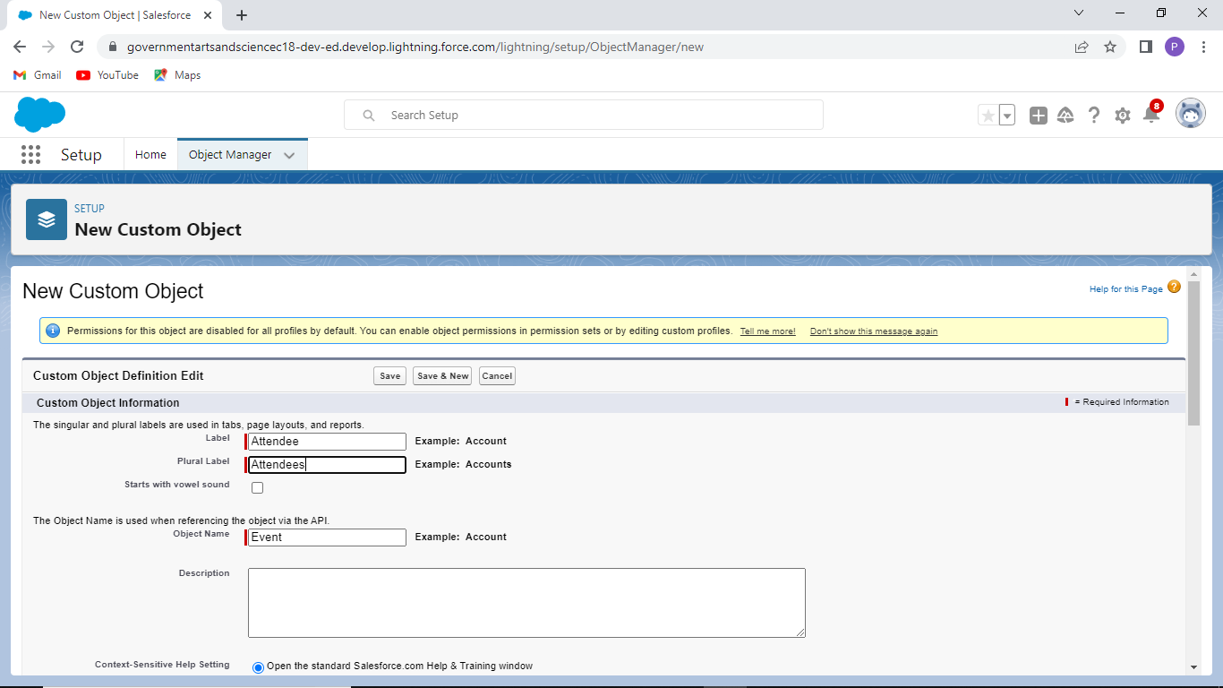

Speakers

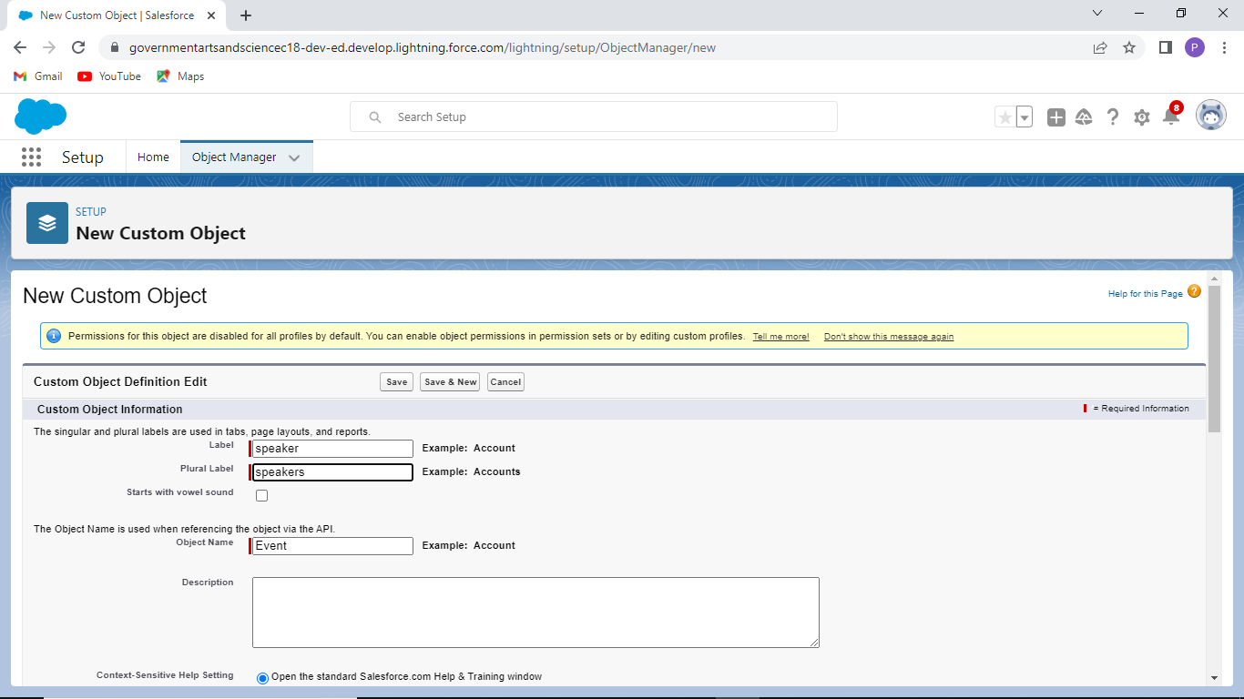

Vendors

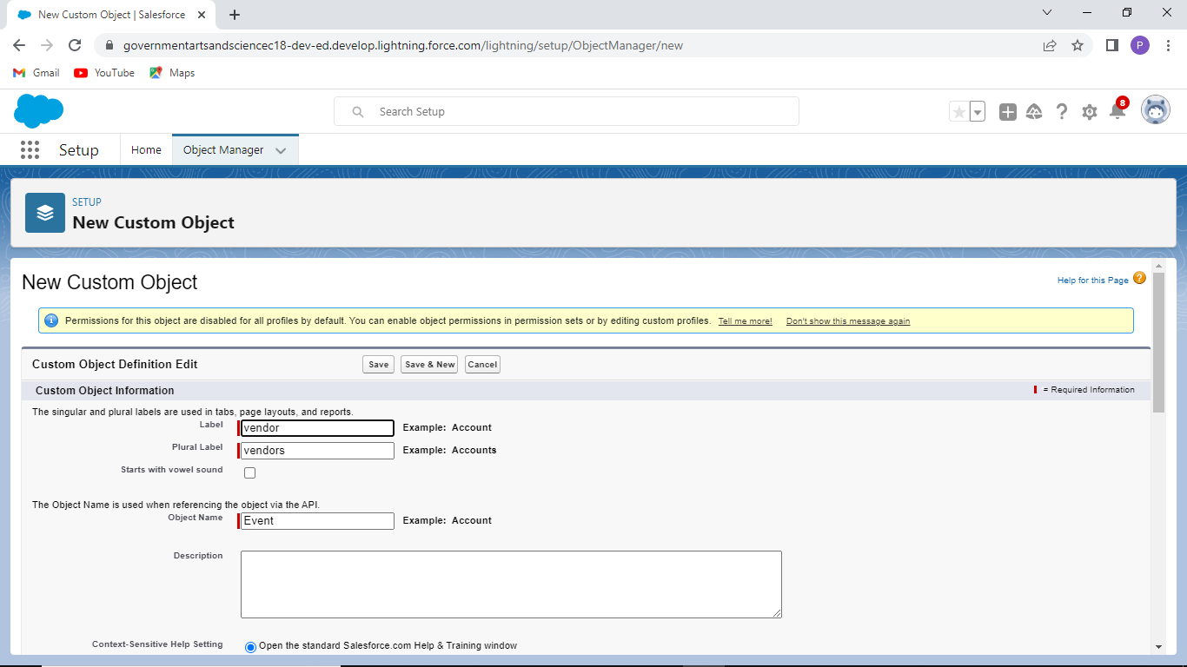

TAB CREATION

In the quick find box we typed tabs and went inside it and clicked new and we gave the required details to create 4 tabs (Events,attendees,speakers,vendors)

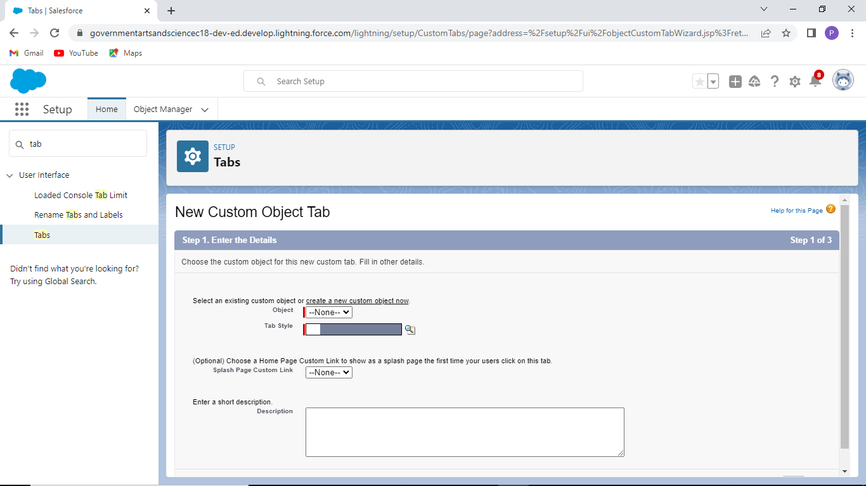

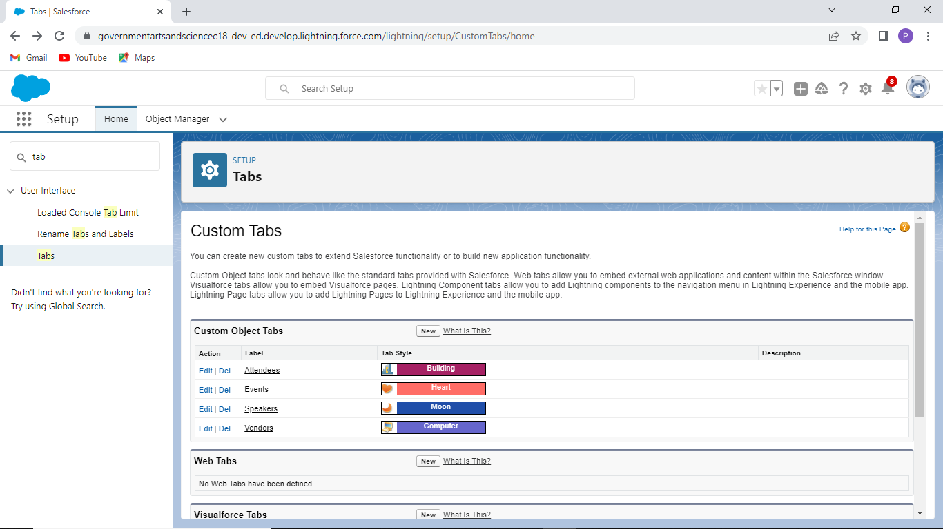

CREATING THE EVENT MANAGEMENT APPLICATION

In the quick find box we typed app manage and went inside it and new lightining app and created an event management application by giving the details

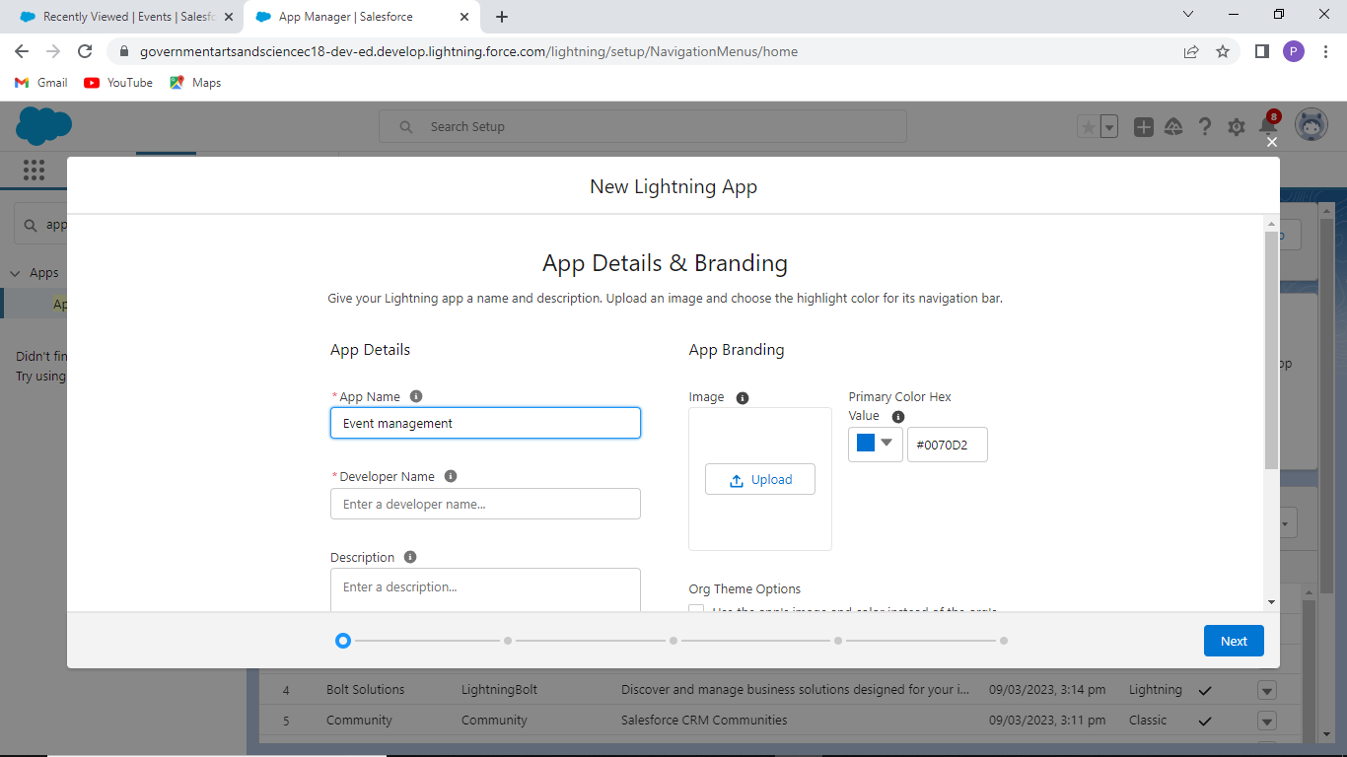

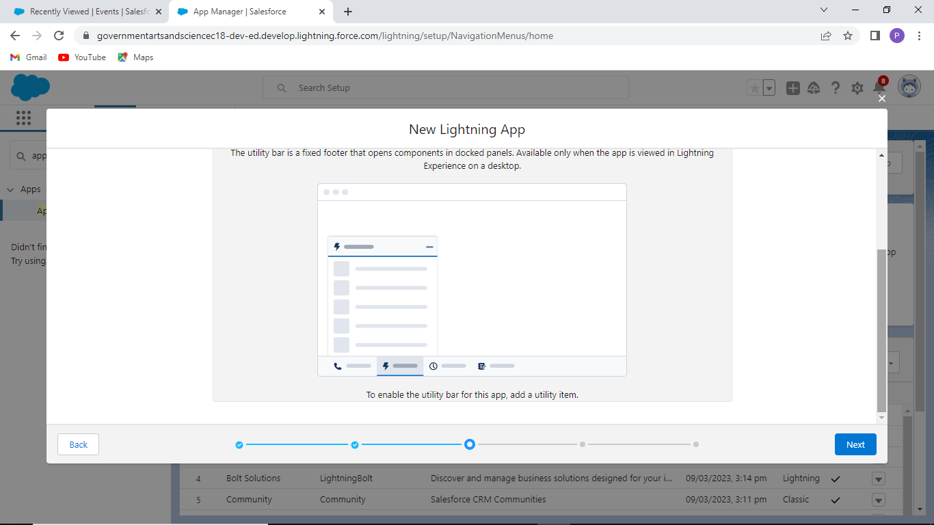

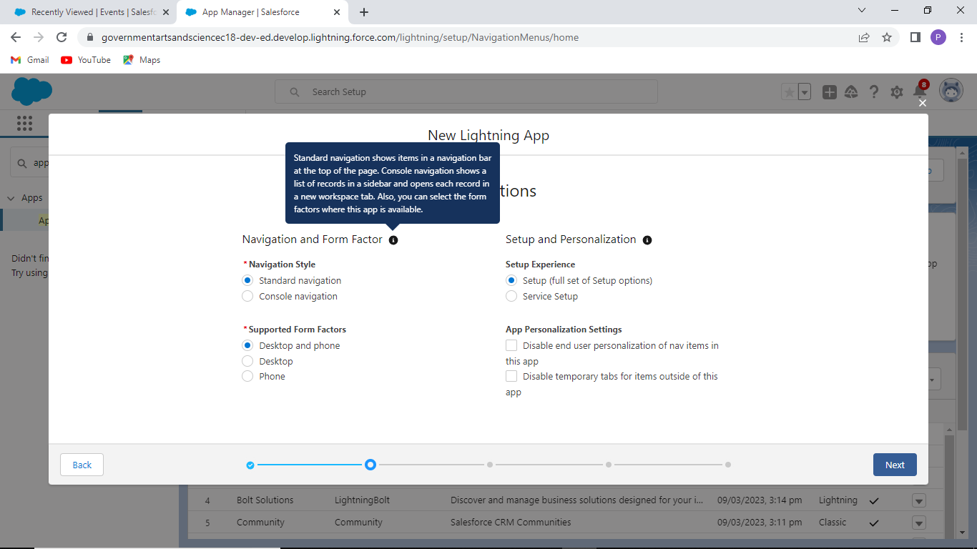

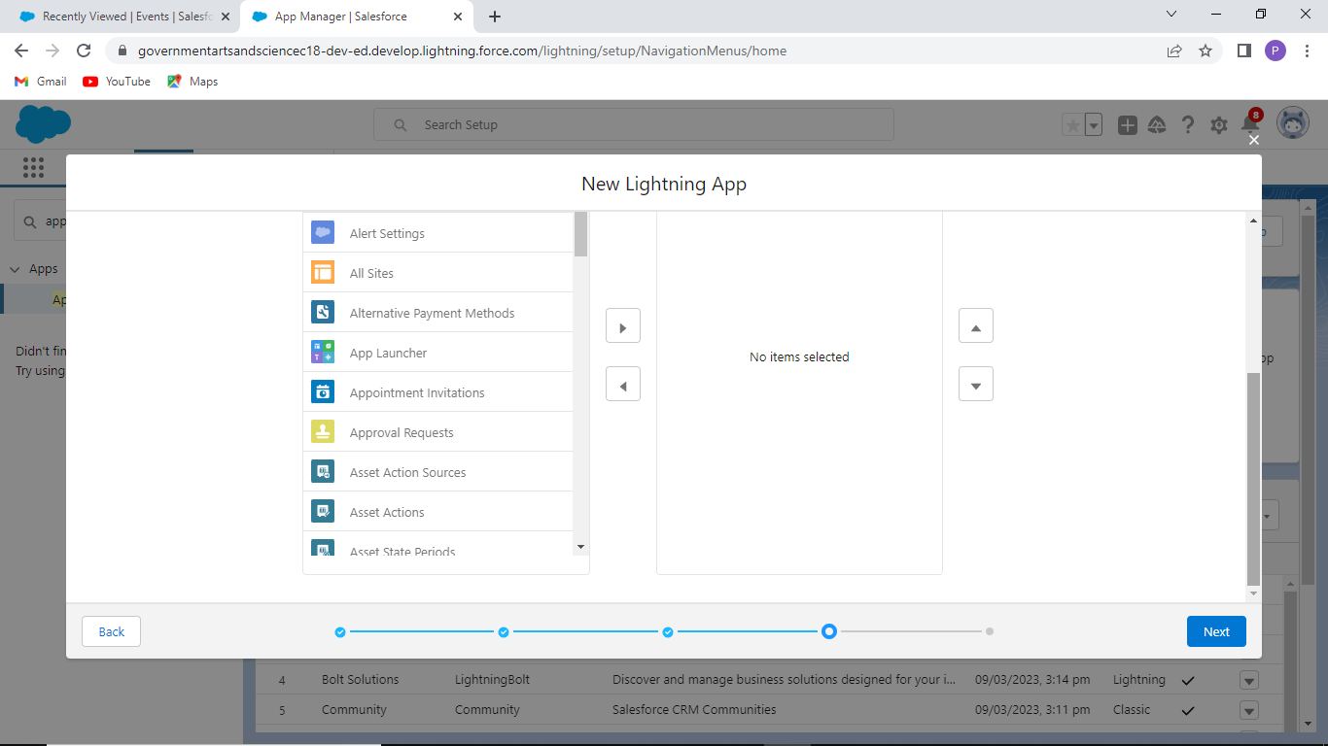

FIELD AND RELATIONSHIP CREATION

In fields and relation ship creation we created 4 field in the event management object.

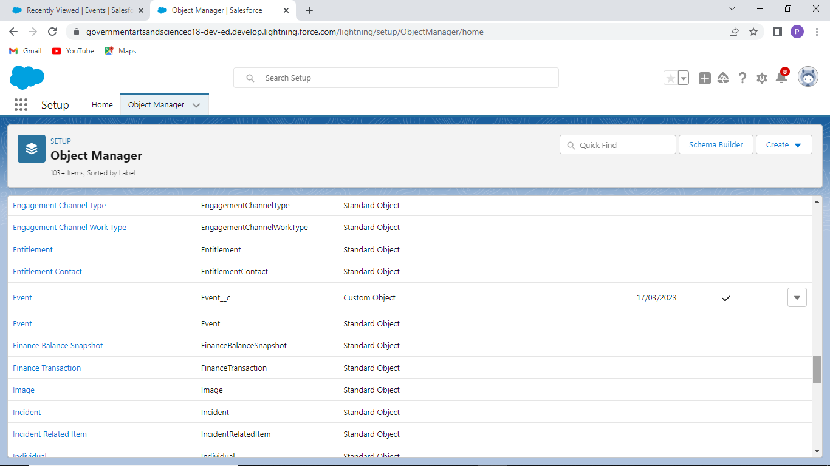

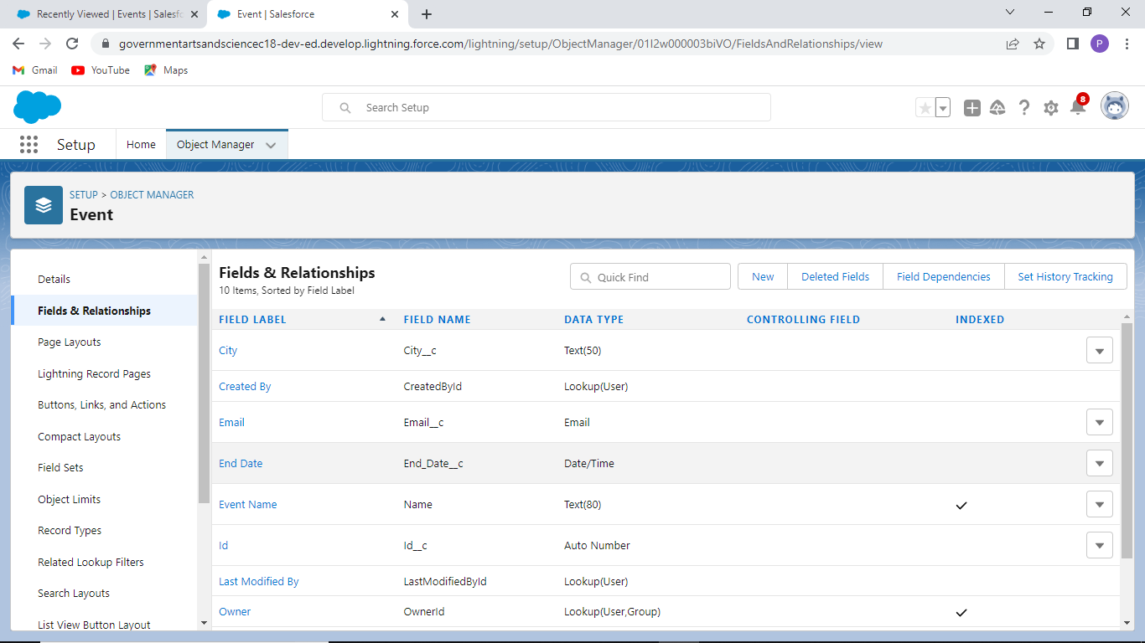

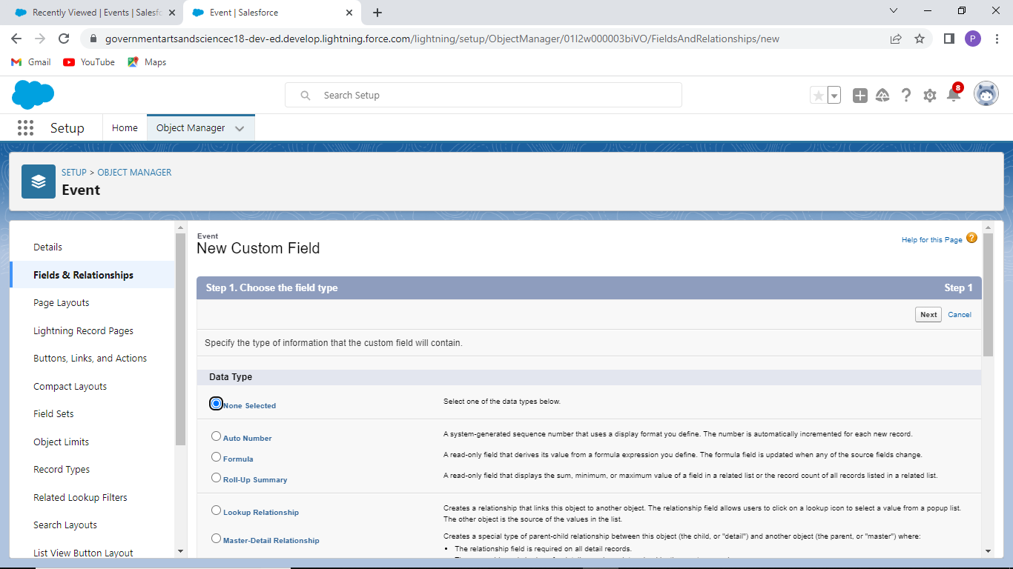

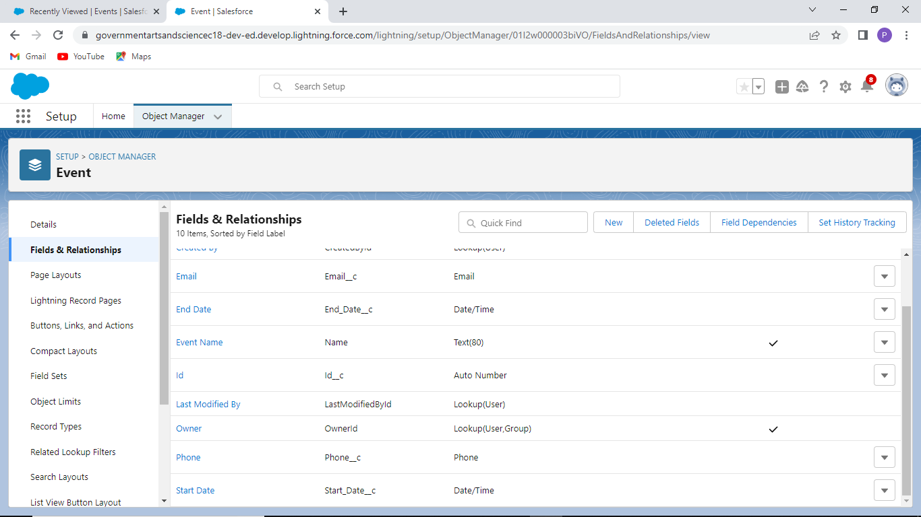

PROFILE CREATION

We create a profile . A profile can be assigned to many users , but user can be assigned single profile at a time.

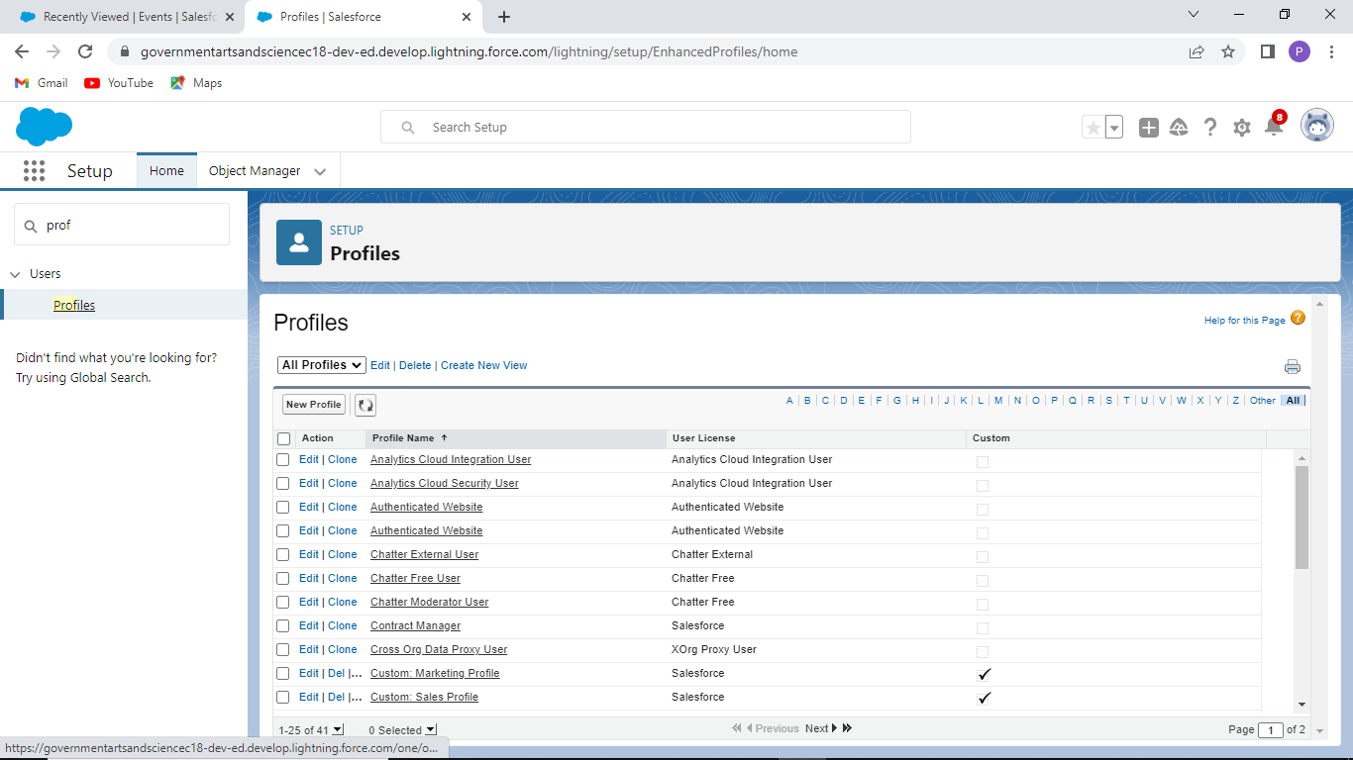

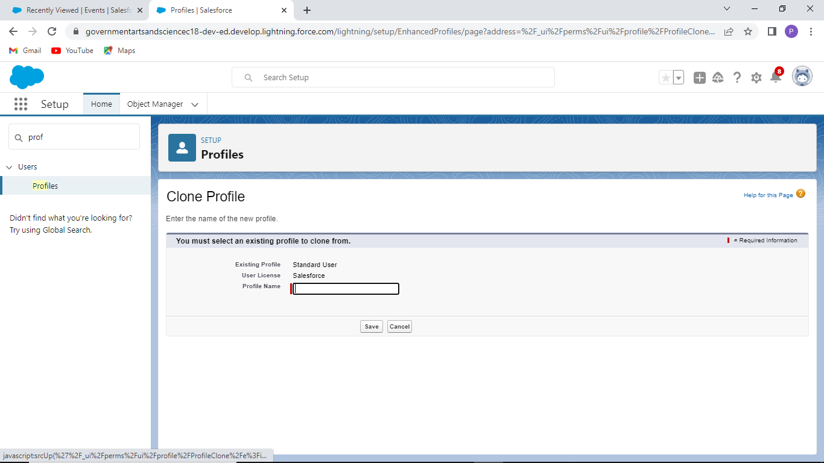

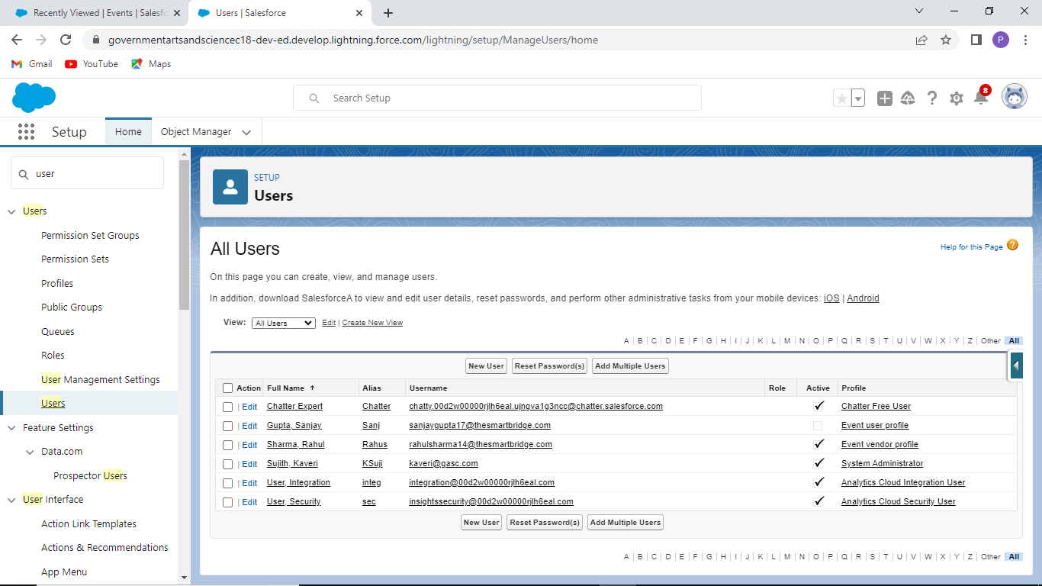

CREATION OF USERS

The user account identifies the user, and the user account settings determine what features and records the user can access.

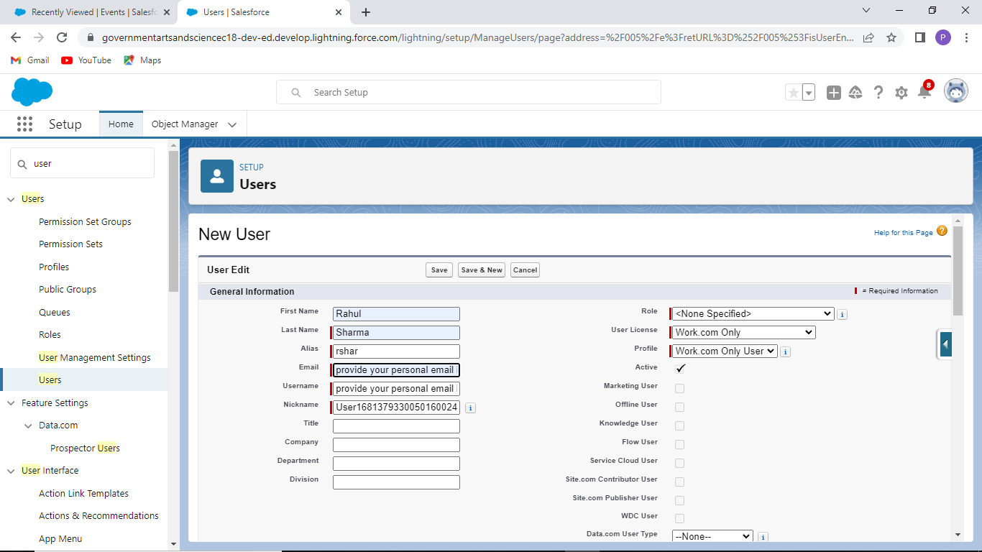



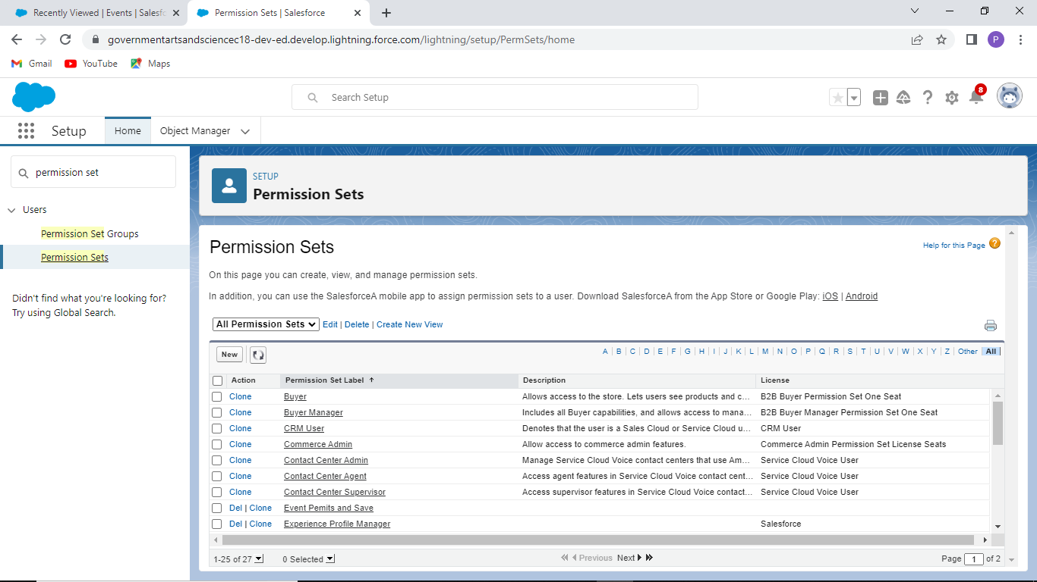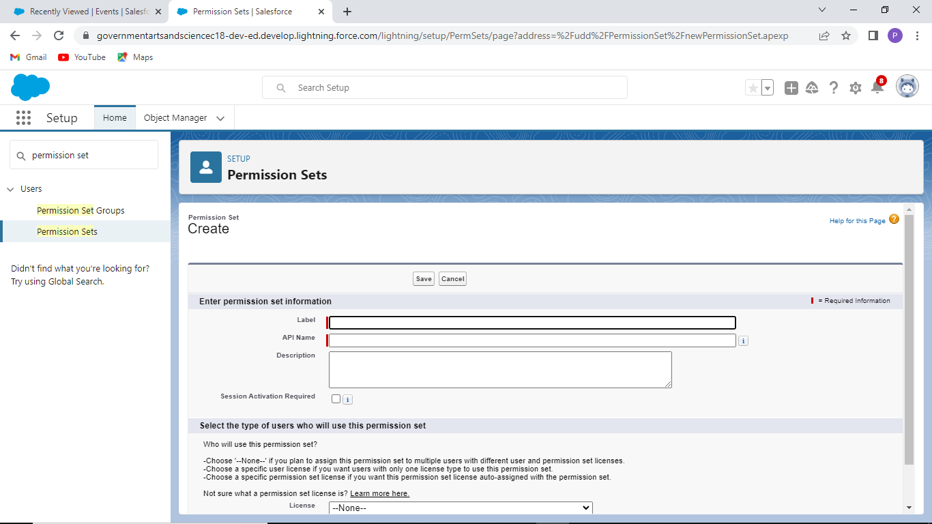

**TRAILHEAD PROFILE PUBLIC URL**

TEAM LEADER : S.KAVERI ; https://trailblazer.me/id/kaveris4

TEAM MEMBER 1 : J.Priyanka

TEAM MEMBER 2 : J.Rajkutty

TEAM MEMBER 3 : M.Muthu

**ADVANTAGES**

* Team management
* Cost – effective
* Approval on time
* Save time
* Increase appliance
* Reduce cost
* Faster process
* Expense is less
* Less paper work

**DISADAVANTAGES**

* Long waiting times
* Restrictions on corporate smartphones
* Platform confusion
* Data must be always on
* Poor internet connectivity causes problem since it is internet dependent
* Poor data synchronization.
* Requesting too many permissions

**APPLICATIONS**

It ease the process of creating and maintaining an event. This process spans from the very beginning of planning all the way to post-event strategizing. At the start, it helps to make planning decisions, such as the time, location, and theme of their event as effortlessly.

A streamlined workflow approval will allow them to spend less time on gaining approvals and the program should also be capable of automatically notifying managers of requests that need their immediate attention.

**CONCLUSION**

By using this app, It is user friendly and cost effective system, it is customized with activities related to event management life-cycle. It provides a new edge to management industry. SolutionDot always keep your objectives and goals on top priority while developing any plan of work.

**SCOPES**

The truth is, event management is a growing industry. As time changes, people are more invested in the quality of experience.

Therefore, one will prefer hiring an event manager to oversee his or her event and deliver an unforgettable experience. This, therefore, is the perfect timing for anyone who wishes to delve into event planning, build a name, and secure a permanent feat in the industry.

People and different companies appreciate the work of event managers which making the future much more promising.